Automotive Consumer Reports 18 / 19-2;
2018 Firegate, Will it be bigger than Dieselgate in 2015?

Imported cars that had been rapidly growing unlikely to suffer much
Consumers with many alternatives, happy to opt to buy other imports
Taking care of BMW owners full of anxiety and complaints as a key
Since the opening of the Korean car market in 1988, imported cars have experienced three major disasters in 30 years. Serious predicaments came along with ‘the IMF crisis in 1997’, ‘the financial crisis in 2008’ and ‘Dieselgate in 2015,’ but the import cars soon overcame such crises to continue to grow afterwards. The imports that were about to come back on with the end of Dieselgate, however, ran into Firegate ignited by BMW. Consumer responses in the first two weeks after the scandal [18/19-1; Benz the second biggest benefinciary of the BMW Firegate, who is the 1st?] did not seem to have much impact on the import car market, overall. However, that was so only when the early responses were looked into. Now, the consequences of the scandal will depend on how to take care of some 400,000 BMW customers who are full of anxiety and complaints.
[Figure 1] Imported car purchase intention & Sales share Trend
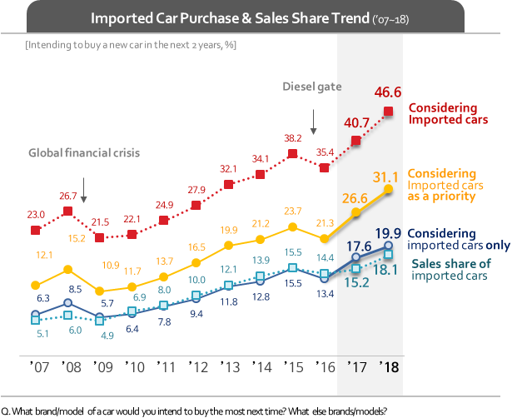
The sales of imported cars have gone down three times. It is a matter of acute interest that whether or not Firegate of this year is to escalate to the fourth mega scandal. Before Firegate happened, the year 2019 seemed like another very bright year for the imports. Some epochal changes were anticipated for 2019, such as ‘considering imports’ outnumbering ‘considering only domestic cars,’ ‘considering imports as priorities possibly ahead of ‘considering Hyundai as a priority,’ with ‘considering only imports’ going over 20% , and the actual sales share of imports surpassing 20%. However, all of those anticipations are now in the thick of uncertainty.
Specifically, of consumers planning to buy a new car in the next two years, some 46.6% of them (29,966) claimed to be intending to buy an import car either as their 1st or 2nd choice [Figure 1]. The figure is the biggest increase by 5.9% points from the previous year’s 40.7%, indicating the momentum in consumers’ intention to buy imported cars. So, had there not been any major problems, the next year seemed to be possibly the first year witnessing the imports showing more than 50% import car purchase consideration over ‘considering only domestic cars’. But, yet, that was a story only when a sudden disaster did not break out.

‘Import car consideration as a priority,’ or purchase intention to buy an import car as a 1st choice accounted for 31.1% of the total purchase intenders. The figure is 4.5% points higher than the previous year’s at 26.6%, going over 30% on the measure for the first time, to close in the gap by 2.4% points with Hyundai (including Genesis) whose purchase intention as a 1st choice standing at 33.5%. If the trend had prevailed, it was very likely that ‘import purchase consideration’ would surpass Hyundai’s in the next year, which has now become a matter of ‘wait and see’.

Some 19.9% of the respondents answered that their 1st and 2nd purchase considerations would be imported cars. The result is smaller than the big rebound (4.2% points) in 2017 after Dieselgate, but still the second biggest bounce-back (2.3% point) in history, implying a great potential for the growth of imported cars. The ratio of ‘considering only imports’ is an important measure in that it is a meaningful companion indicator of the actual sales share of imported cars. The sales share of imported cars was close to going above 20%, which, however, remains unknown for now.

It is possible that Firegate of this year could evolve into a mega disaster, but the initial reactions of those intending to buy import cars do not look so serious. If you have a problem with a certain brand, you can choose another brand. Rather, the biggest problem is that there are nearly 400,000 owners of the concerned brand and their anxiety and complaints do not seem to be at any ordinary level. The majority of them see that there can be a fire in their cars as well, expect the price of their used cars to drop by more than 20%, and refuse to accept the Dieselgate-type compensation in the past, considering legal solutions through litigation. Many changes will be under way, depending on how to relieve their anger and disappointment.

==============================================================
◈ Reference: 「Consumer Insight」 Annual Automobile Syndicated Study Outline
The contents was excerpted and summarized from the results of ‘Annual Syndicated Automobile Study’ conducted by Consumer Insight Inc. in every July since 2001.

